 |  |  |  |  | 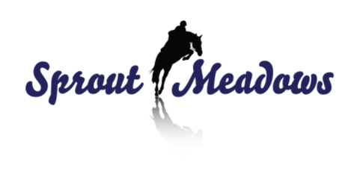
To Register Online: please print off form and scan a copy of the completed form with online payment confirmation # to sprout-meadows@hotmail.com
 |  |  |  |  |  | Office use Only:
Registration via mail: Send completed application and payment to |  |  |  |  |  | Camp Date:
 |  | Sprout Meadows |  |  |  | Deposit rec'd
 |  | 6851 Sprout Rd |  |  |  | Full Payment Rec'd |  | post-Dated Cheque Rec'd
 |  | Courtenay, BC V9J 1N3
Camper's Personal Information
Last Name: |  |  | First Name: |  |  | Birthdate: |  |  | Sex:
Street Address: |  |  |  |  |  |  |  | City:
Province: |  |  |  | Postal Code: |  |  | Home Phone:
Camper's Contact Information
Name of First Parent or Guardian |  |  |  |  | Email Address
Home Phone: |  |  |  |  | Cell/Daytime Phone
Name of Second Parent or Guardian |  |  |  |  | Email Address
Home Phone: |  |  |  |  | Cell/Daytime Phone
Name of Third Parent or Guardian |  |  |  |  | Email Address
Home Phone: |  |  |  |  | Cell/Daytime Phone
Camper's Riding History
Never Ridden |  |  |  | Previous Discipline Ridden |  | English
Couple Group Trail Rides |  |  |  |  |  | Western
1-3 mos. |  |  |  |  |  | Unknown
3-6 mos.
6mos-1yr
1yr plus
Cancellation Policy and Refunds
In the event of a cancellation, refunds will be made according to the following schedule (percentage is of total camp fee):
Time of Cancellation |  |  |  |  | Amount of Refund
More than 6 before camp start date |  |  |  |  | Camp fee less the 25% deposit
2-6 weeks before camp start date |  |  |  |  | 50% of camp fee less the 25% deposit
Less than 2 weeks before camp start date |  |  |  |  | No refund, unless with a physician’s note / unavoidable circumstances @ discretion of Sprout Meadows
 |  |  |  |  |  |  |  | I have read and understand the cancellation policy
Payment Information
Pay by Credit Card: |  | The total camp fee must accompany the registration form, online confirmation number must be noted on the registration form
 |  | * all credit card payments must be made online at www.SproutMeadows.com
Pay by Cheque Cash E-transfer: |  | A non-refundable, non-transferable deposit must accompany the registration, (25% of the camp fee per person.) the balance must also accompany the registration, post-dated no later than start date of the camp.
 |  | * all cheque payments must be made out to Patricia Cowland and delivered direct in person or mailed
 |  | * all cash payments must be made direct to Sprout Meadows
 |  |  |  |  |  | Camp Fee…….. | $
 |  |  |  |  |  | +5% GST….. | $
 |  |  |  |  |  | TOTAL: | $
ALL Camper's - Medical Information for EACH Child
Last Name: |  |  |  | First Name: |  |  |  | Birthdate:
Doctor's Name: |  |  |  |  |  | Dr's Phone #:
Personal Health Number (care card):
Allergies (to drugs, food, animals, etc). Be specific. |  |  | Reaction/Severity |  |  | Treatment/Medication required
Please check here if the camper carries
 |  |  | Does camper know how to use?
 | ANA Kit |  |  | Yes |  | No
 | Epipen |  |  | Yes |  | No
 | Medic alert bracelet
Immunization History
Has Camper received all immunizations required by public health? (if no please explain)
 | Yes |  | No
Date of last tetanus (MM/DD/YY)
Parent's or Guardian's Declaration
* In the case of medical or surgical emergency, I understand every effort will be made to contact the parents it guardians on this form. In the even that none can be reached, I give permission to have the above named camper sent to be sent to hospital via 911 and a ambulance call. (all ambulance fees are the responsibility of the camp or camper(s) parent's or guardian(s)
* in the interest of health and safety, I give permission for this health information to be shared with appropriate camp staff or outside medical personnel
* I will notify the camp if the applicant is exposed to an infectious disease during the three weeks prior to the start of camp
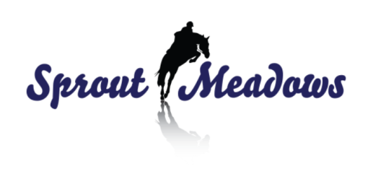
* to the best of my knowledge, the applicant is in good health and physically able to participate in call camp activities, except as noted above. I will notify the camp if any of the above information changes prior to start of camp date

ACKNOWLEDGMENT OF RISK AND RELEASE OF LIABILITY
“ FOR PARTICIPANTS 18 YEARS OR YOUNGER”

PLEASE ccc
INFANT PARTICIPANT’S NAME: _____________________________DATE OF BIRTH:______________________
INFANT’S ADDRESS:_________________________ CITY:______________ PROV: ________POSTAL:________

GUARDIAN’S NAME:______________________________________DATE OF BIRTH:_____________________
GUARDIAN’S ADDRESS:______________________ CITY:______________ PROV:_________ POSTAL:_______

THE GUARDIAN MUST READ AND UNDERSTAND PRIOR TO THE INFANT PARTICIPATING IN EQUINE ACTIVITIES

To:_______________________________ (NAME OF PERSON, ORGANIZATION OR COMPANY PROVIDING THE EQUINE ACTIVITIES)

their directors, employees, officers, volunteers, business operators, and site property owners. (collectively called the HOST)

INITIAL EACH ITEM BELOW AFTER READING AND UNDERSTANDING THE ITEM

____1. I am the Parent and/or Legal Guardian of the infant Participant named above and am executing this form on behalf of the infant Participant in my capacity as parent and/or guardian and with the intent that this form be binding on myself and infant Participant for all legal purposes.

____2. I Understand there are Inherent DANGERS, HAZARDS and RISKS, (collectively called RISKS) associated with Equine Activities and injuries resulting from these “RISKS” are a common occurrence.

____3. I Acknowledge that the Inherent “RISKS” of Equine Activities mean those DANGEROUS conditions which are an integral part of Equine Activities, including but not limited to:
•The propensity of any equine to behave in ways that might result in injury, harm or death to persons on or around them and to potentially collide with, bite or kick other animals, people, or objects.
•The unpredictability of an equine’s reaction to such things as sounds, sudden movement, tremors, vibrations, unfamiliar objects, persons or other animals and hazards such as subsurface objects.
•The potential for other participant (s) to act in a negligent manner that might contribute to injury to themselves or others, such as failing to act within their ability or to maintain control over an equine.
cfBBfBmfmc
____4. I Freely Accept and Fully Assume All Responsibility for the Inherent “RISKS” and the possibility of personal injury, death, property damage or loss which might result from the infant being a Participant.

____5. I Acknowledge that it remains my Sole Responsibility for the safety of the infant Participant and for the infant to Participate within his/her own limits.

____6. In addition to consideration given for the infant to Participate in Equine Activity, I and my heirs, executors, administrators and assigns (collectively called my “Legal Representatives”) agree
•To Waive All Claims that I or the infant Participant might have against the “HOST”; and
•To Release the “HOST” from Any and All Liability for any loss, damages, injury, or expense that I, the infant Participant or our “Legal Representatives” might suffer as a result of the infant’s Participation due to any cause including any NEGLIGENCE ON THE PART OF THE “HOST”; and
•To HOLD HARMLESS AND INDEMNIFY THE “HOST” from any and all liability for property damage or personal injury to the infant Participant or to any third party which might result from the infant’s Participation.

Before signing this form I read it (as indicated by my initials above) and I stated that I understand it. I further state I am aware that signing this form, waives certain legal rights I and/or the infant Participant and/or our “Legal Representatives” might have against the “HOST”.

SIGNED_______________________________________ This day__________________ of 20_________

_______________________________________________ ___________________________________
(PRINT NAME OF HOSTWITNESS TO SIGNING & INITIALING) (SIGNATURE OF PARTICIPANT)

_______________________________________________ ___________________________________
(Signature of HOST Witness) (Signature of Parent/Guardian)

DO NOT SIGN UNTIL YOU UNDERSTAND ALL ITEMS ABOVE

