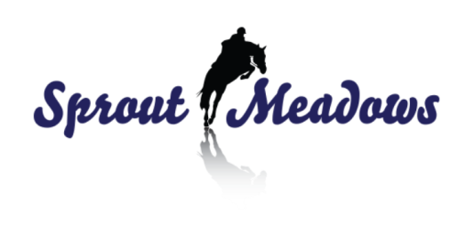
ACKNOWLEDGMENT OF RISK AND RELEASE OF LIABILITY
“ FOR PARTICIPANTS 18 YEARS OR YOUNGER”

INFANT PARTICIPANT’S NAME: _____________________________DATE OF BIRTH:______________________
INFANT’S ADDRESS:_________________________ CITY:______________ PROV: ________POSTAL:________

GUARDIAN’S NAME:______________________________________DATE OF BIRTH:_____________________
GUARDIAN’S ADDRESS:______________________ CITY:______________ PROV:_________ POSTAL:_______

THE GUARDIAN MUST READ AND UNDERSTAND PRIOR TO THE INFANT PARTICIPATING IN EQUINE ACTIVITIES

To:__Sprout Meadows_________ (NAME OF PERSON, ORGANIZATION OR COMPANY PROVIDING THE EQUINE ACTIVITIES)

their directors, employees, officers, volunteers, business operators, and site property owners. (collectively called the HOST)

INITIAL EACH ITEM BELOW AFTER READING AND UNDERSTANDING THE ITEM

____1. I am the Parent and/or Legal Guardian of the infant Participant named above and am executing this form on behalf of the infant Participant in my capacity as parent and/or guardian and with the intent that this form be binding on myself and infant Participant for all legal purposes.

____2. I Understand there are Inherent DANGERS, HAZARDS and RISKS, (collectively called RISKS) associated with Equine Activities and injuries resulting from these “RISKS” are a common occurrence.

____3. I Acknowledge that the Inherent “RISKS” of Equine Activities mean those DANGEROUS conditions which are an integral part of Equine Activities, including but not limited to:
•The propensity of any equine to behave in ways that might result in injury, harm or death to persons on or around them and to potentially collide with, bite or kick other animals, people, or objects.
•The unpredictability of an equine’s reaction to such things as sounds, sudden movement, tremors, vibrations, unfamiliar objects, persons or other animals and hazards such as subsurface objects.
•The potential for other participant (s) to act in a negligent manner that might contribute to injury to themselves or others, such as failing to act within their ability or to maintain control over an equine.

____4. I Freely Accept and Fully Assume All Responsibility for the Inherent “RISKS” and the possibility of personal injury, death, property damage or loss which might result from the infant being a Participant.

____5. I Acknowledge that it remains my Sole Responsibility for the safety of the infant Participant and for the infant to Participate within his/her own limits.

____6. In addition to consideration given for the infant to Participate in Equine Activity, I and my heirs, executors, administrators and assigns (collectively called my “Legal Representatives”) agree
•To Waive All Claims that I or the infant Participant might have against the “HOST”; and
•To Release the “HOST” from Any and All Liability for any loss, damages, injury, or expense that I, the infant Participant or our “Legal Representatives” might suffer as a result of the infant’s Participation due to any cause including any NEGLIGENCE ON THE PART OF THE “HOST”; and
•To HOLD HARMLESS AND INDEMNIFY THE “HOST” from any and all liability for property damage or personal injury to the infant Participant or to any third party which might result from the infant’s Participation.

Before signing this form I read it (as indicated by my initials above) and I stated that I understand it. I further state I am aware that signing this form, waives certain legal rights I and/or the infant Participant and/or our “Legal Representatives” might have against the “HOST”.

SIGNED_______________________________________ This day__________________ of 20_________

_______________________________________________ ___________________________________
(PRINT NAME OF HOSTWITNESS TO SIGNING & INITIALING) (email/cell # for Barn Communication)

_______________________________________________ ___________________________________
(Signature of HOST Witness) (Signature of Parent/Guardian)

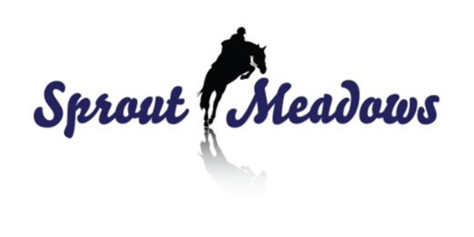
DO NOT SIGN UNTIL YOU UNDERSTAND ALL ITEMS ABOVE

ACKNOWLEDGMENT of RISK and RELEASE of LIABILITY
“FOR PARTICIPANTS 19 OR OLDER”

PLEASE PRINT CLEARLY
PARTICIPANT’S NAME:___________________________________ DATE OF BIRTH:_______________________
ADDRESS:_____________________________________________
CITY:_________________________________________________
PROV:______________ POSTAL CODE:____________

EVERY PERSON MUST READ AND UNDERSTAND THIS FORM BEFORE PARTICIPATING IN EQUINE ACTIVITIES

To:______Sprout Meadows____________________________________________________________________
(Name of Person, Organization or Company providing the Equine Activities)

their directors, employees, officers, volunteers, business operators, and site property owners. (collectively called the HOST)

INITIAL EACH ITEM BELOW AFTER READING AND UNDERSTANDING THE ITEM

____1. I Understand there are Inherent DANGERS, HAZARDS and RISKS, (collectively called RISKS) associated with Equine Activities and injuries resulting from these “RISKS” are a common occurrence.

____2. I Acknowledge that the Inherent “RISKS” of Equine Activities mean those DANGEROUS conditions which are an integral part of Equine Activities, including but not limited to:
•The propensity of any equine to behave in ways that might result in injury, harm or death to persons on or around them and to potentially collide with, bite or kick other animals, people, or objects.
•The unpredictability of an equine’s reaction to such things as sounds, sudden movement, tremors, vibrations, unfamiliar objects, persons or other animals and hazards such as subsurface objects.
•The potential for other participant (s) to act in a negligent manner that might contribute to injury to themselves or others, such as failing to act within their ability or to maintain control over an equine.

____3. I Freely Accept and Fully Assume All Responsibility for the Inherent “RISKS” and the possibility of personal injury, death, property damage or loss resulting from my Participation in Equine Activities.

____4. I Acknowledge that it remains my Sole Responsibility to act in such a manner as to be responsible for my own safety and to Participate Within My Own Limits.

____5. In addition to consideration given for my Participate in Equine Activity, I and my heirs, executors, administrators and assigns (collectively called my “Legal Representatives”) agree
•To Waive All Claims that I might have against the “HOST”; and
•To Release the “HOST” from Any and All Liability for any loss, damages, injury, or expense that I or my “Legal Representatives” might suffer as a result of my Participation due to any cause whatsoever including any NEGLIGENCE ON THE PART OF THE “HOST”; and
•To HOLD HARMLESS AND INDEMNIFY THE “HOST” from any and all liability for property damage or personal injury to any third party which might result from my Participation in Equine Activities.

Before signing this form I read it (as indicated by my initials above) and I stated that I understand it. I know that signing this form, waives certain legal rights I or my “Legal Representatives” might have against the “HOST”.

SIGNED_______________________________________ This day__________________ of 20_________

_______________________________________________ __________________________________________
(PRINT NAME OF HOSTWITNESS TO SIGNING & INITIALING) (SIGNATURE OF PARTICIPANT)

_______________________________________________ __________________________________________
(SIGNATURE OF HOSTWITNESS) (email/cell # for Barn Communication)

DO NOT SIGN UNTIL YOU UNDERSTAND ALL ITEMS ABOVE

